Marcus Miller

**Bet Exchange Patent**

**Summary**

A system that allows groups of people to make bets with other people in the same group and bet type. Every spread bet has a favorite and underdog that can be based on many things. For our system the favorite and underdog is determined by the spead selected by the bettor. The bettor with the lower betting odds is considered the favorite. The winnings from a bet come from the lossings of the matched bet order. One advantage of group based bet matching is to have limited liability because the system doesn’t need to match bet payoffs. An advantage to the user is they can select their minimum odds as part of their betting criteria. Games and events have betting buckets. Betting buckets are either spread or over/under bets. Win bets are converted into spread bets. Betting buckets include a group name which only users in that group can make bets within that bucket. The default group includes everyone. Bets that haven’t been filled yet can be canceled. Matched bets can be canceled if another order fills the canceled bet’s position. Partial cancellations are possible. Cancellations are not guaranteed. Bets may be unmatched if a fraudulent bet order to fill is involved. The system will have an API to allow third party applications to make bets for the user. The system will have a cash reserve to pay off fraudulent bets. The system may be integrated with an insurance company to submit fraudulent claims automatically. The system will automatically collect scores and make pay-offs. The system will allow bets to automatically be made for a user if they select an odds maker for the betting bot to use. The user can select maximum amounts per game that the betting bot can make. For example a user could set an ESPN analyst as their trusted odds maker and a maximum wager amount per game of $1. The betting bot will then place orders to fill that meet the odds maker’s criteria. This allows the user to use betting as a long term investment in theory because winnings can automatically be placed into new bets. The user puts money into the system for the betting bot to bet and the betting bot continuously makes bets with the money. Bet orders to fill that aren’t matched by the end of the game will be canceled and the wager amount available for use to the user.

**Terms** (Mathematical notation in brackets [ ])

**Game** = an activity in which an individual or team competes against another or others. [**g**]

**Game Outcome** = the way a *game* turns out. [**gOutcome**]

**Game Outcomes** = The set of all possible outcomes for a *game*. [**gOutcomes**]

**Game Teams** = The set of teams that make up a *game*. [**gTeams**]

**Bettor** = A person betting on a game or outcome.

**Bet** = contract between bettors on the basis of the outcome of a future *game*.

**Bet Order** = A bet that matches only if the minimum decimal odds are satisfied.

**Betting Currency** = The unit of currency that is used for wagers, payouts, profits, escrows, or other amounts mentioned. [**$**]

**Bettor selectedTeam** = the selected team for a spread or win bet. **[selectedTeam]**

**Bettor’s Selected Game Outcomes** = The set of possible game outcomes that the bet creator bets on to happen.

**Bettor’s Decimal Odds** = The odds selected by the bet's creator. [**odds, o**]

**Bettor Wager Amount** = The wager amount selected by the Bet's creator. [**wager, w**]

**Bet Payout** = The bettor’s decimal odds times the wager amount. [**payout**]

**Bet Creator Profit** = The bet payout for a bet minus wager amount minus the platform fee. [**profit**]

**Escrow Amount** = The wager amount for the bet. The escrow amount is unavailable to the user until the bet is finished or canceled. **[eAmount]**

**Filled isUnderdog**= *true if bettor isUnderdog equals false else false* [**-U**]

**Filled Game Outcomes** = The set of possible game outcomes minus the game outcomes selected by the bet creator.

**Filled Decimal Odds** = The odds another bet will need to satisfy to match with this bet . [**fOdds**]

**Filled Wager amount** = The wager amount that needs to be bet by other bettors. [**fWager**]

**Filled Payout** = The total amount paid out from a bet to the other bettor if they win. Same value as payout. [**fPayout**]

**Filled Profit** = The total amount paid out to the other bettor if they win. Filled Profit equals Filled Payout minus Filled Wager minus platform fee amount [**fProfit**]

**Bet Exchange** = A system for creating betting orders between two or more bettors. [**betEx**]

**Platform Fee** = The amount the bet exchange charges in betting currency to place a bet. [**pFee**]

**Matched Bet Order** = Two bet orders have matched on a bet for a game. [**matchedBet**]

**Account Value** = The balance of the bettor to bet.

**Bet Winner** = The Bettor that selected the game outcome that occurred. [**winner**]

**Bet Loser** = The Bettor that didn’t select the correct game outcome. [**loser**]

**Bet Winner Payout** = The Bet Winner’s profit [**wPayout**]

**Bet Loser payout** = Bet Loser loses the escrow amount paid for the bet. [**lPayout**]

**Formulas**

eAmount = wager

fOdds = odds / (odds - 1)

fWager = wager * (odds - 1)

teams = proper subset of game teams

fTeams = The set difference between gTeams and teams

outcomes = proper subset of game outcomes

fOutcomes = The set difference between game outcomes and outcomes

If (bettor wins)

payout = wager + fWager

profit = fWager - pFee

fPayout = 0

fProfit = -fWager

wPayout = profit

Else {

payout = 0

profit = -wager

fPayout = wager + fWager

fProfit = wager - pFee

wPayout = fProfit

}

**Relationship Between the Components**

Bettors create bet orders with the bet exchange that are matched with other bet orders to create bets. A bet order will match with the complement betting orders. If a bet can’t be matched for the full amount (fWager) the bet order will be split. The matching amount will create a bet and the remaining amount will be placed on a new bet order. Events and games have different betting buckets. Buckets are separated by type and spread or over/under amount if applicable for bet type. Bet orders are placed into betting buckets based on the bet type (straight up, over/under, spread) and spread or over/under amount. For example a straight up bet would be placed in the straight up bucket. An over/under bet order with a 50.5 over/under amount would be placed into the over/under 50.5 bucket. Bet orders can only match with other bet orders within the same bucket. An over/under bet order with a 49.5 over/under amount would be placed into the over/under 49.5 bucket. Bet orders can only match with other bet orders within the same bucket. A matching bet order that has decimal odds less than the new bet order will be matched with the new bet order’s filled odds to create a bet. Buckets can be made private to only allow certain users to bet in.

**Potential Applications**

Betting on eSports, elections, weather, casino games, financial statements results, number of views, and game show results. Casino games such as roulette would not start until bet orders were matched. over/under for financial statements profits or revenues.

Select a game to bet on.

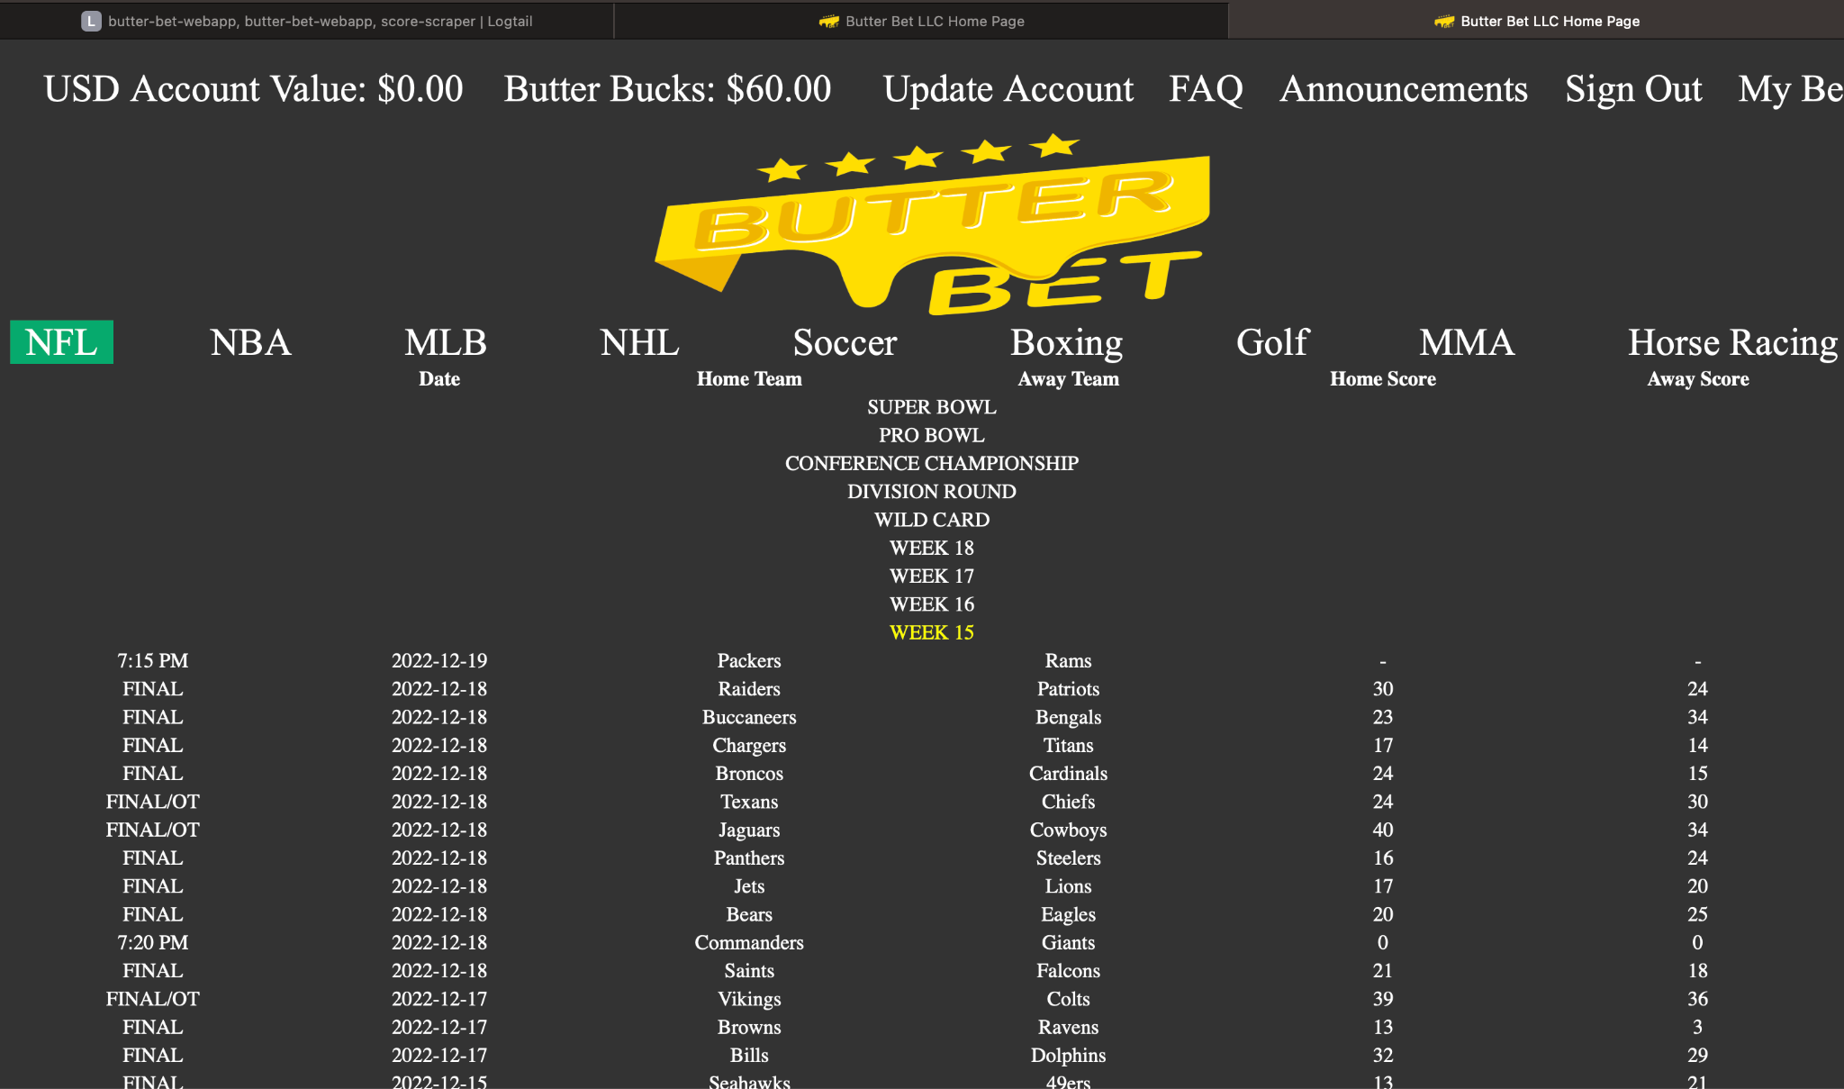

Select bet and adjust spread or over/under if required.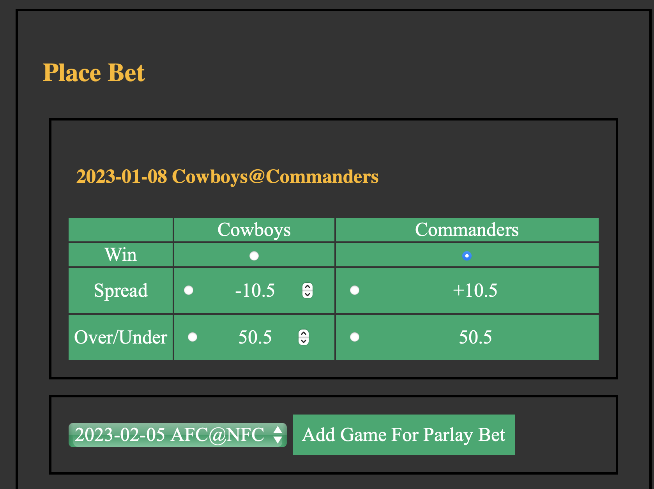

Bet payoff if order is filled.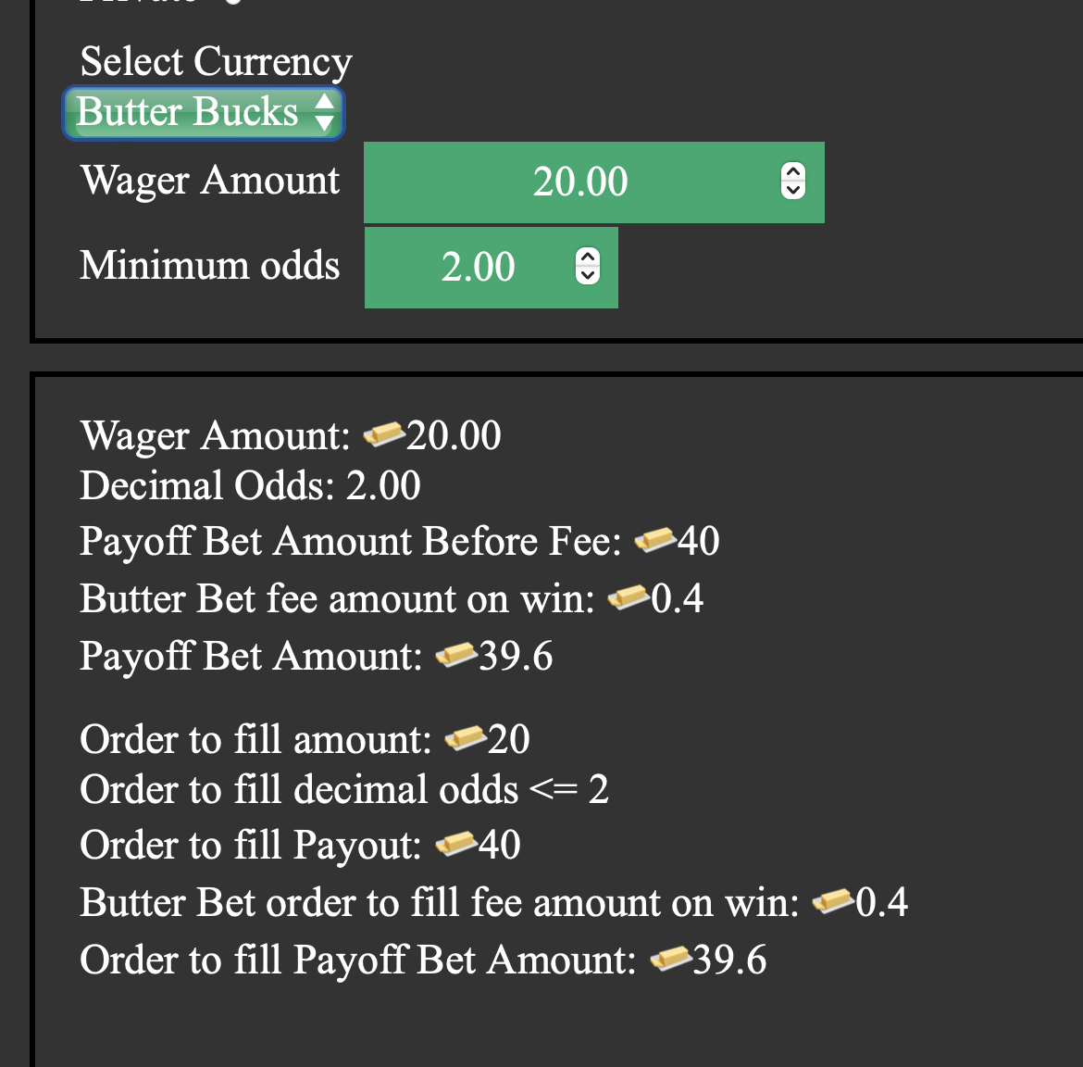

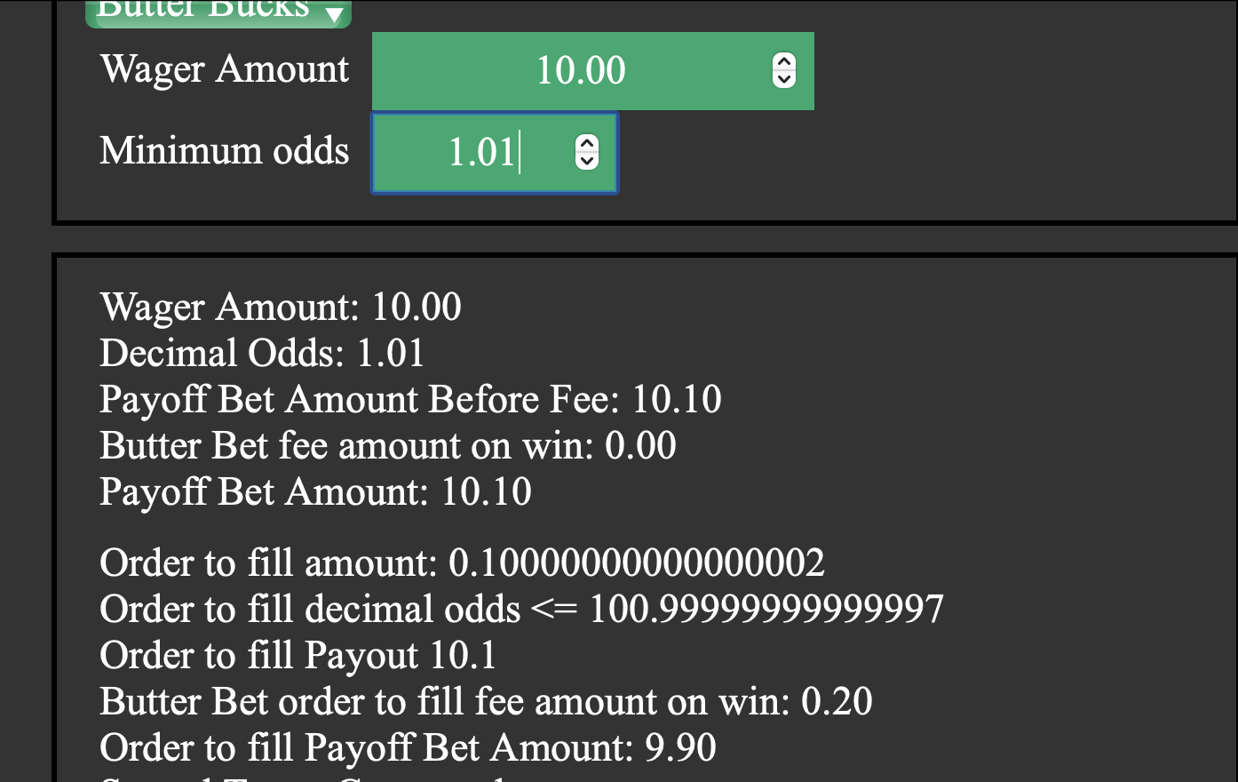

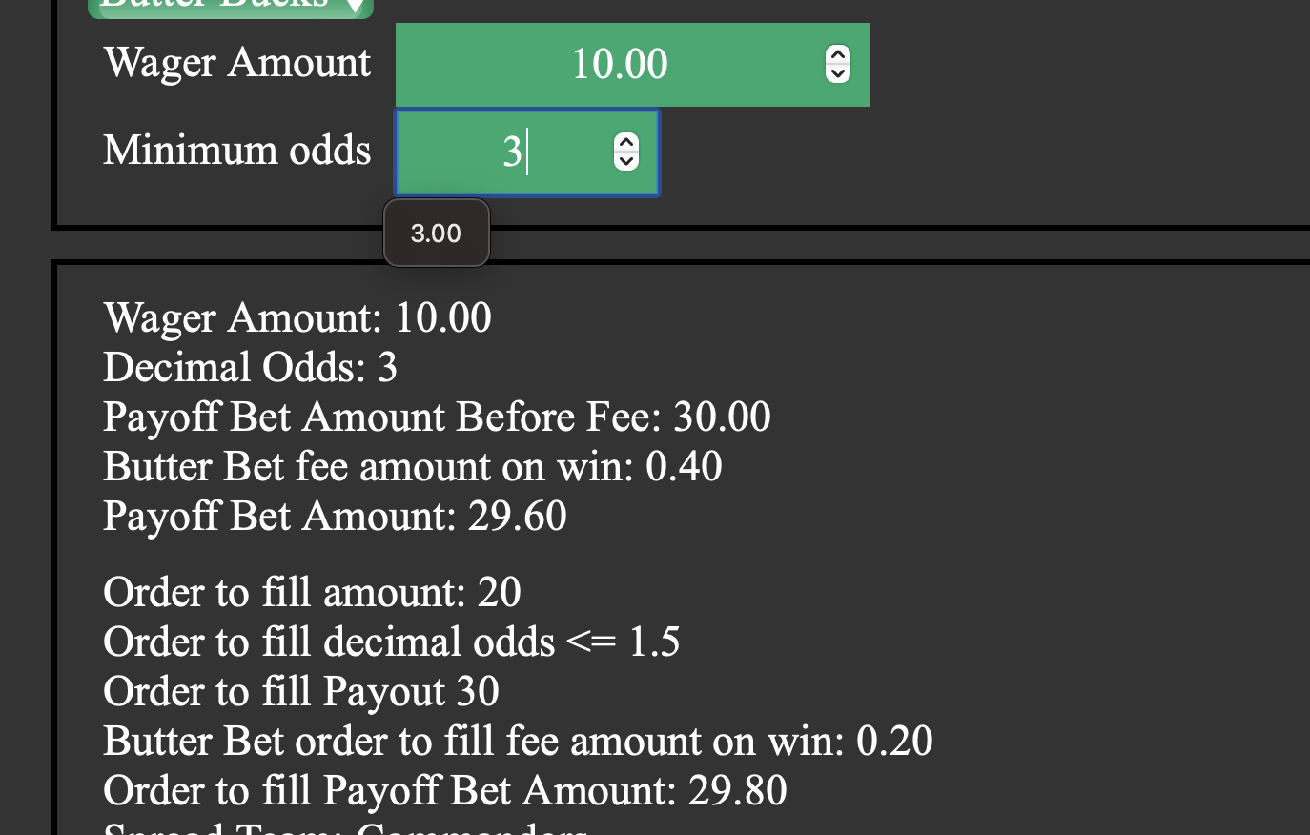

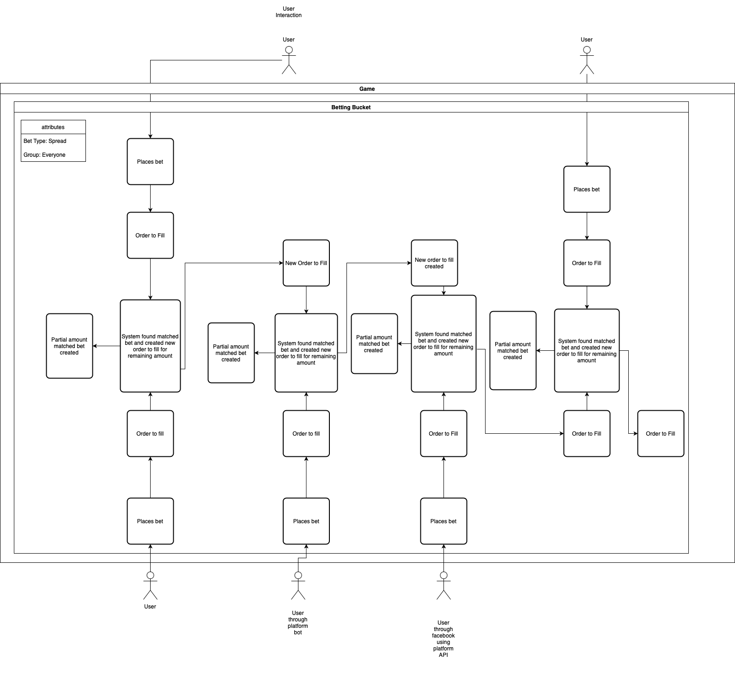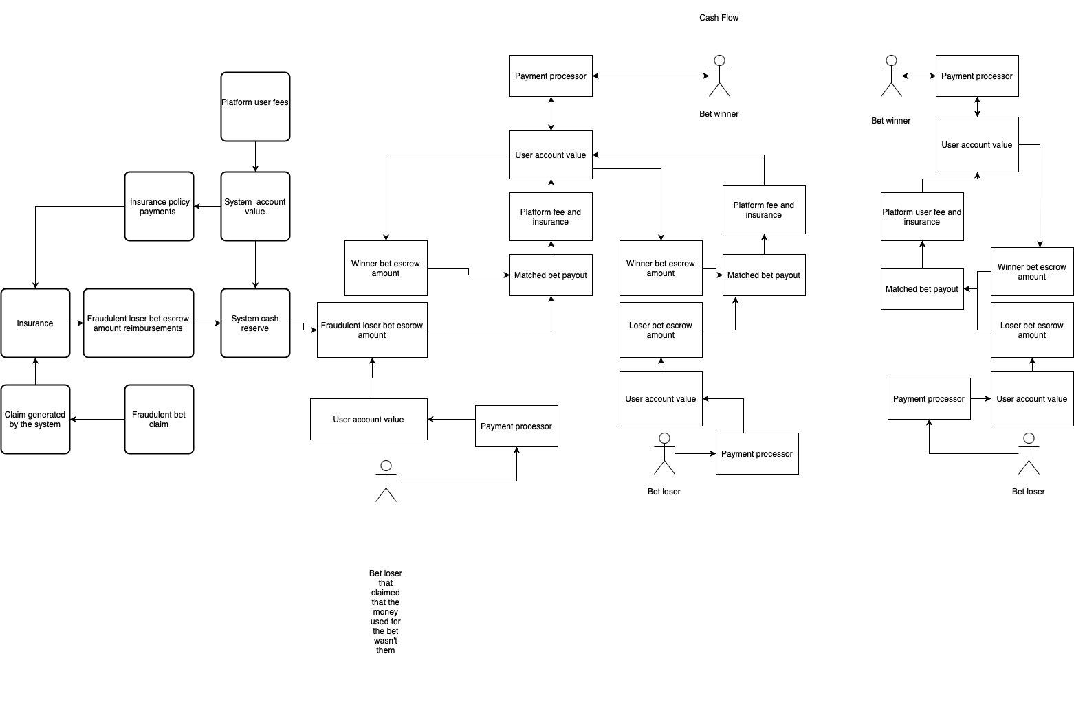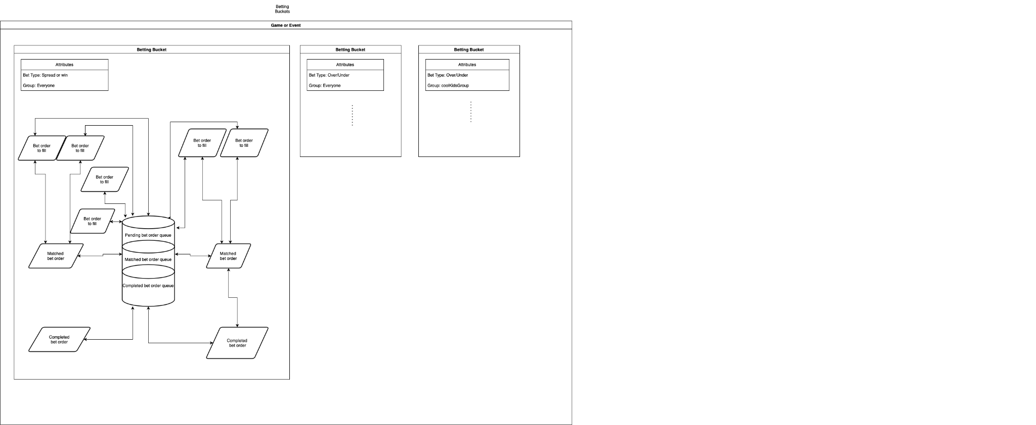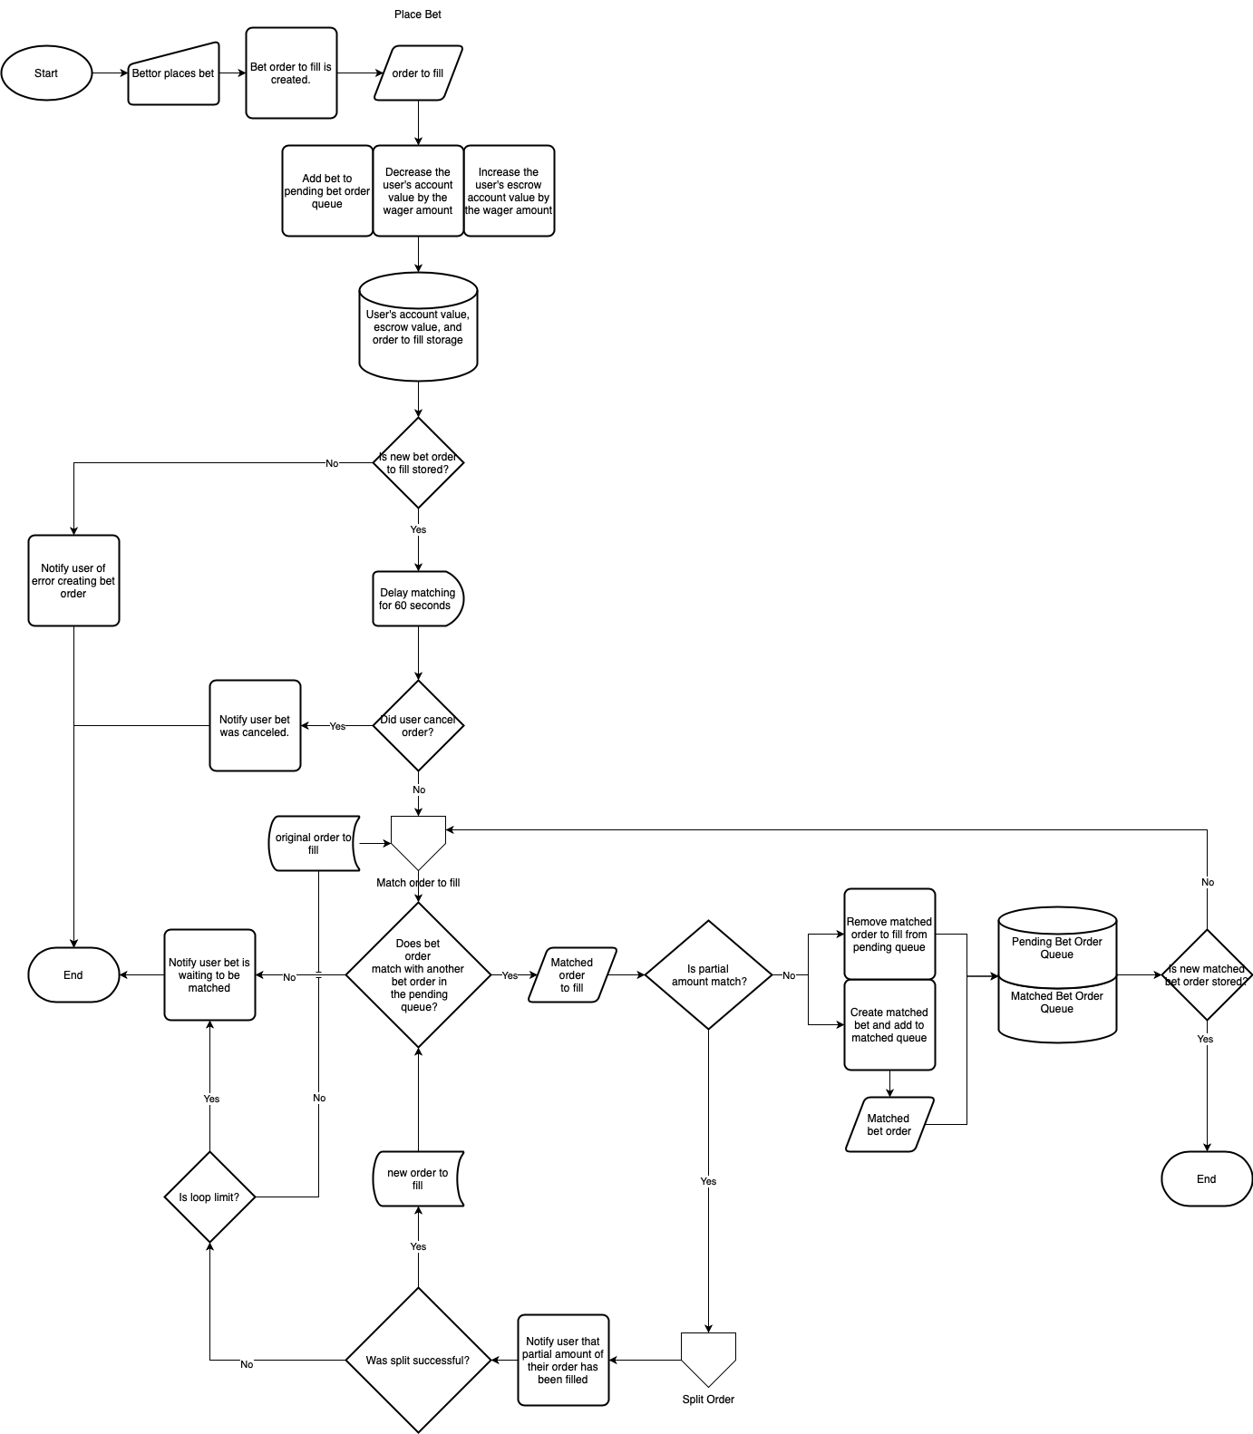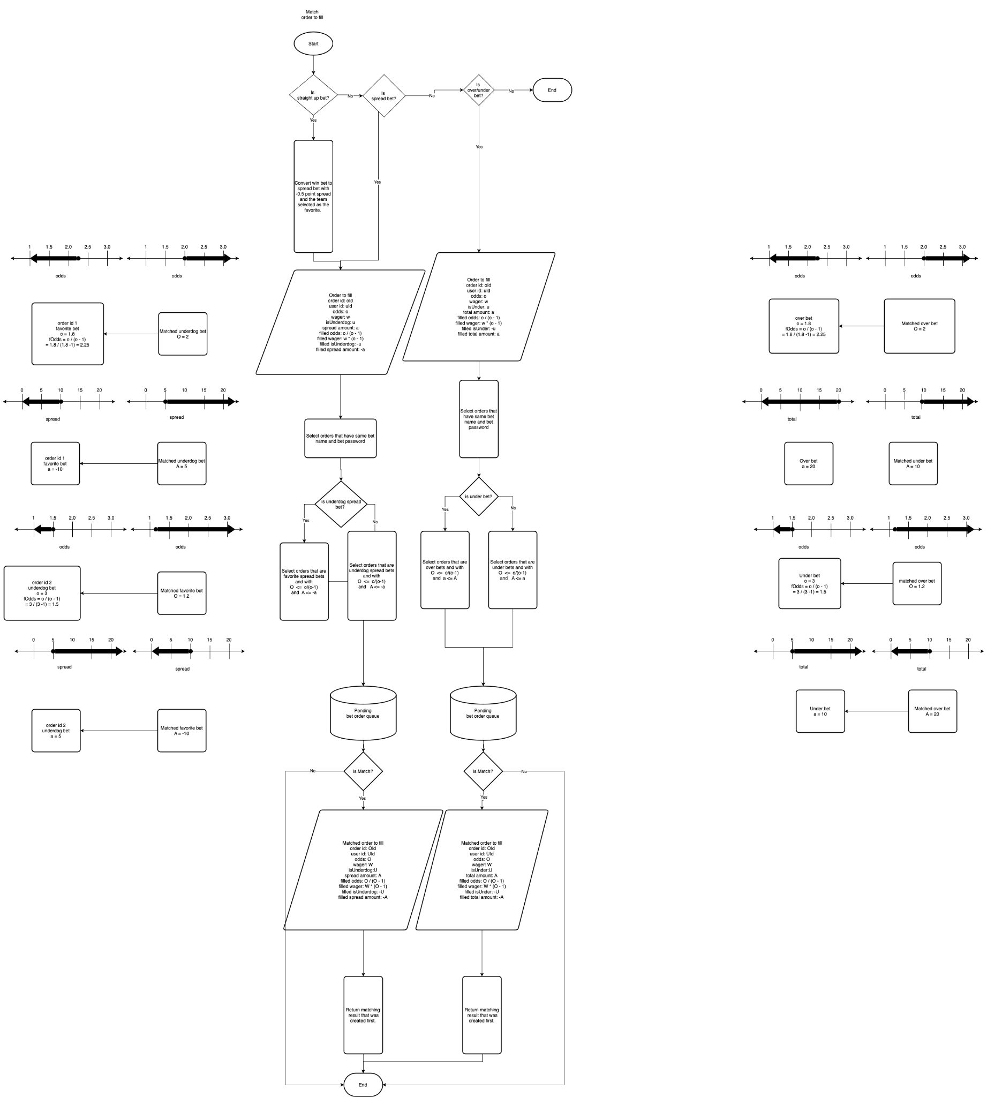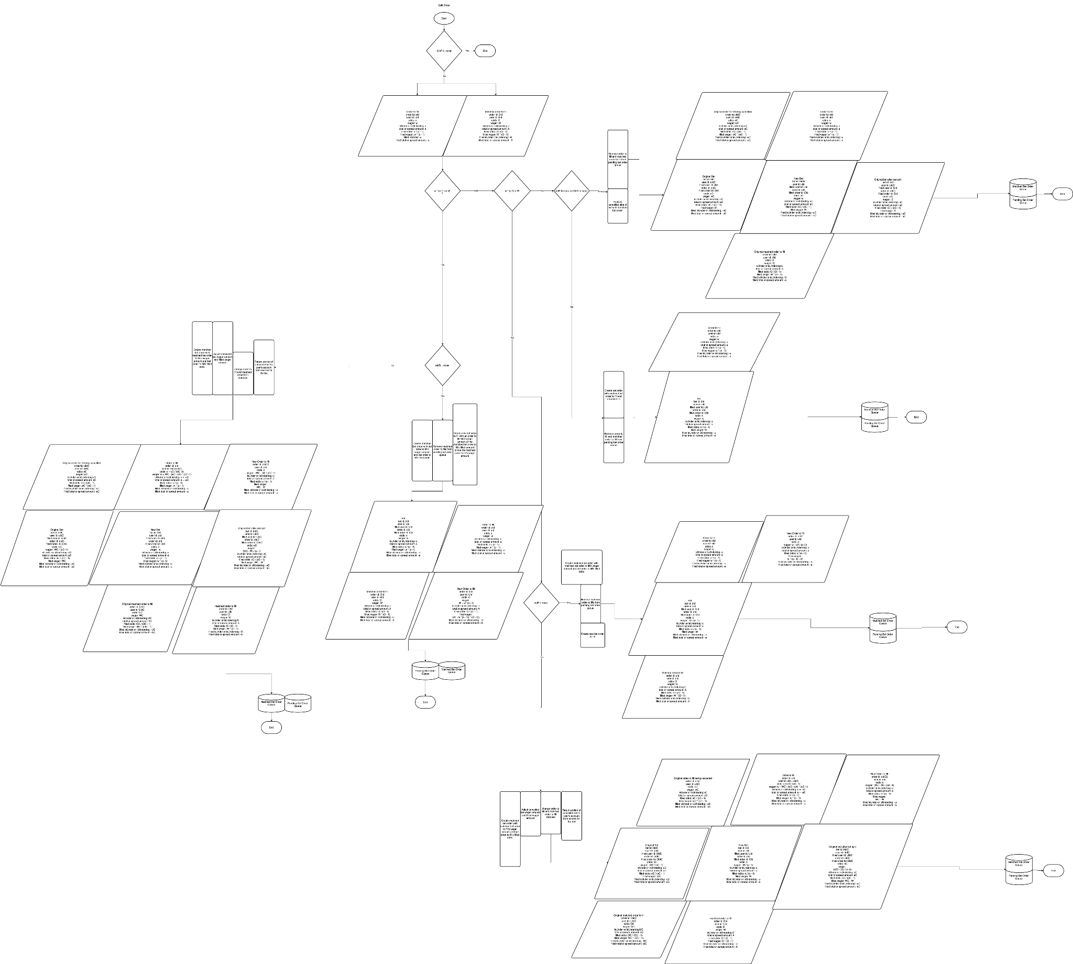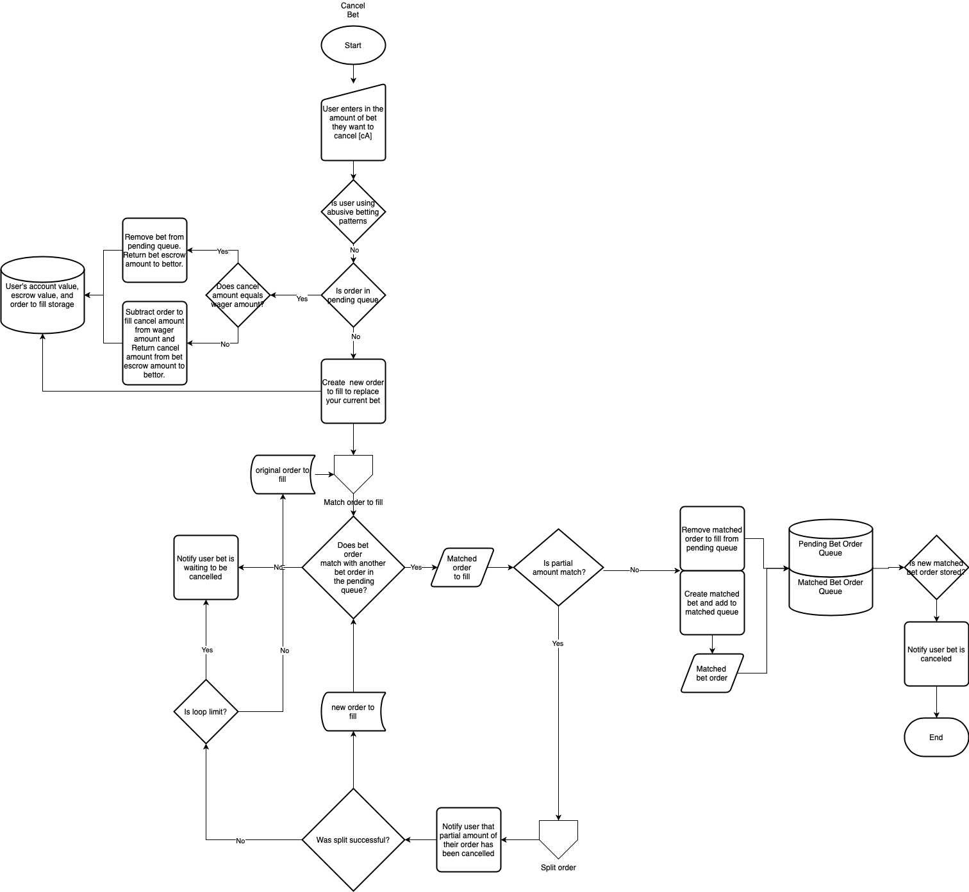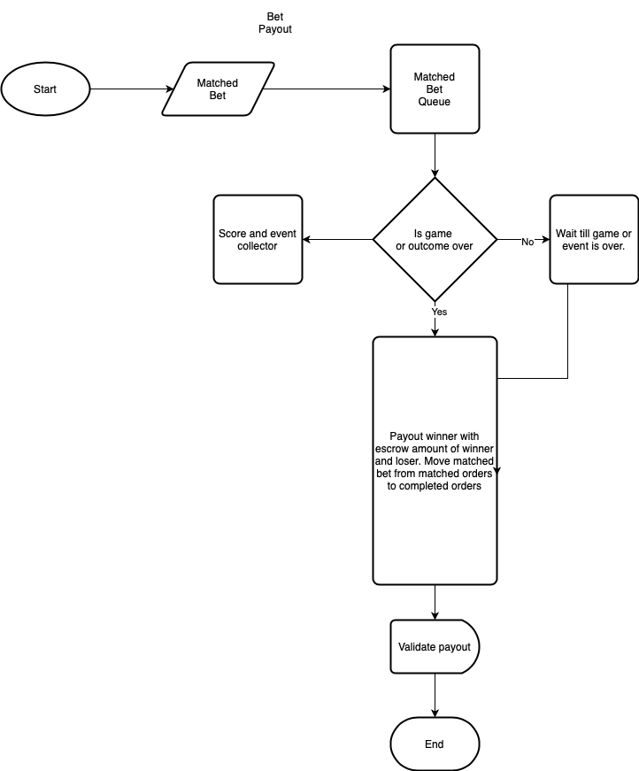

**Football Betting Example Straight Up Bet Type Converted to Spread**

Game 1: Seahawks vs Rams

Scenario: Customer 1 wants to bet that the Seahawks will win against the Rams. The customer wants to bet even odds before the platform fee. Win bet gets converted into a -0.5 pt spread bet with 2.0 decimal odds.

Betting Fee Percent = 1%

Sport = Football

Football Outcome Set = {Seahawks lose, tie, or win}

Football Complement Outcome Matching =

Game Teams = {Seahawks, Rams}

Game Complement Team Matching =

{

Seahawks ⇔ Rams

}

Over/Under Complement Matching =

{

over ⇔ under

}

Bettors = {bettor1, bettor2, bettor3}

**State 0 of Bet Exchange**

**Available Bets On Exchange**

None

**Escrow Amounts**

bettor1 = $0

bettor2 = $0

bettor3 = $0

**Account Balance**

bettor1 = $20

bettor2 = $20

bettor3 = $10

**Bet Creator Action 1**

**Bet Orders to fill on the exchange**

**Scenario**

bettor1 creates a $20 bet order for the Seahawks to win against the Rams at 2.0 decimal odds**.**

Bet creator = bettor1

orderId = 1

Bet isUnderdog = false

Bet selected team = Seahawks

Bet bet type = spread

Bet spread amount = -0.5

Bet selected decimal odds = 2.0

**State 1 of Exchange**

**Bet Orders to fill on the exchange**

{orderId:1, odds: 2.0, team: Rams, spread: -0.5, wager: $20}

**Escrow Amount**

bettor1 = $20

bettor2 = $0

bettor3 = $0

**Account Balance**

bettor1 = $0

bettor2 = $20

bettor3 = $10

**Bet Creator Action 2**

**Bet Orders to fill on the exchange**

{orderId:1, odds: 2.0, team: Rams, spread: -0.5, wager: $20, bettor: 1}

**Scenario**

bettor2 also thinks the Seahawks will win or tie with even odds and creates a $20 bet.

Bet = bettor2

orderId = 2

Bet = isUnderdog = true

Bet selected teams = Seahawks

Bet bet type = spread

Bet spread amount = 0.5

Bet selected decimal odds = 2.0

Bet escrow = $20

Filled odds = 2.0

**State 2 of Exchange**

**Bet Orders to fill on the exchange**

{orderId:1, odds: 2.0, team: Rams, spread: -0.5, wager: $20, bettor: 1}

{orderId:2, odds: 2.0, team: Rams, spread: 0.5, wager: $20, bettor: 2}

**Escrow Amount**

bettor1 = $20

bettor2 = $20

bettor3 = $0

**Account Balance**

bettor1 = $0

bettor2 = $0

bettor3 = $10

**Bet Creator Action 3**

**Bet Orders to fill on the exchange**

{orderId:1, odds: 2.0, team: Rams, spread: -0.5, wager: $20, bettor: 1}

{orderId:2, odds: 2.0, team: Rams, spread: 0.5, wager: $20, bettor: 2}

**Scenario**

bettor3 thinks the Rams will win and places a bet for the Rams to win with even odds and wagers $10.

Both bet1 and bet2 are possible matches because the bettor wants to bet on the Rams team and the other bets are for the Seahawks. Since bet1 came first bet1 will be accepted for $10 and another bet will be created for bettor1 for the remaining wager amount of $10 ($20 wagered - $10 of wager accepted). $10 from bettor3’s account value will also be put in escrow for potential losses.

**State 3 of Exchange**

**Bet Orders to fill on the exchange**

{orderId:1, oddsToFill: 2.0, team: Rams, spreadToFill: -0.5, wagerToFill: $20, betAgainst: 1}

{orderId:2, oddsToFill: 2.0, team: Rams, spreadToFill: 0.5, wagerToFill: $20, betAgainst: 2}

{orderId:3, oddsToFill: 2.0, team: Seahawks, spreadToFill: 0.5, wagerToFill: $10, betAgainst: 3}

{orderId:4, oddsToFill: 2.0, team: Rams, spreadToFill: -0.5, wagerToFill: $10, betAgainst: 1}

**Bet Orders Matched on the exchange**

{filledOrderId:1, orderId:1, oddsBettor1: 2.0, bettor1Team: Seahawks, spread: -0.5, bettor1Wager: $10, orderId:3, oddsBettor2: 2.0, bettor2Team: Rams, bettor2Wager: $10}

**Pending Game Results Bets**

bet between bettor1 and bettor3

**Escrow Amount**

Bettor 1 = $20

Bettor 2 = $20

Bettor 3 = $10

**Account Balance**

Bettor 1 = $0

Bettor 2 = $0

Bettor 3 = $0

**Game Start**

When the game starts any available bets that have not been accepted will be canceled and escrow money returned to the bettor. No more bets can be created once a game starts.

**State 4 of Exchange**

**Available Bets On Exchange**

**Pending Game Results Bets**

Bet1 between bettor 1 and bettor 3.

**Escrow Amount**

Bettor 1 = $10

Bettor 2 = $0

Bettor 3 = $10

**Account Balance**

Bettor 1 = $10

Bettor 2 = $20

Bettor 3 = $0

**Game End**

Game outcome: Seahawks win.

**State 3 of Exchange**

**Available Bets On Exchange**

None (game is over)

**Pending Game Results Bets**

None (game is over)

**Escrow Amount**

bettor1 = $0

bettor2 = $0

bettor3 = $0

**Platform Fee Amount**

**Bettor 1 profit $10.00 * 1% platform fee percent = $0.10 revenue**

**Account Balance**

bettor1 = $30

bettor2 = $20

bettor3 = $0